Training Database

Developed for companies to manage training needs, schedules and completions

Contact: John Mitchell – 248-644-8092




1360 Puritan Ave, Birmingham, Michigan 48009; Phone: 800-328-9696 or 248-644-8092; Fax: 248-644-3209
Web: http://www.mitchellsell.com Email: john@mitchellsell.com
Training Database
Table Of Contents

SECTION DESCRIPTION PAGE

I. Databases: Microsoft Access................................................................................. 4
Understanding Databases........................................................................... 4
Terms……………….........................................................................…… 4
Principles Of Good Database Design.......................................................... 5
Normalization............................................................................................. 6
Network users…………............................................................................. 6
Field Recommendations.............................................................................. 7
Data Entry Recommendations..................................................................... 8
Access Features.......................................................................................... 9
Relationships …………………………………..………………………………. 10
Access Shortcuts........................................................................................ 10
Queries....................................................................................................... 11
Forms ……………................................................................................... 13
Reports ………………………………………………….……………………… 14
Printing Multi-Column Reports................................................................... 16
Mail Labels................................................................................................. 17
Macros....................................................................................................... 18
Importing And Exporting Records.............................................................. 18
Merge/Purging To Remove Duplicates …………………………………. 19
What You Can Do With Your Database...................................................... 20

- The Training Database
Tables and Queries…............................................................................. 21
Relationships…………............................................................................. 22
Panel…………………..……................................................................…… 23
FrmMain with Contacts tab........................................................................ 23
FrmMain with Actions tab…........................................................................ 24
FrmMain with Notes tab….......................................................................... 24
FrmMain with Classes tab……….….......................................................... 25
FrmMain with ClassCode Drop-Down.......................................................... 25
FrmEnterClasses………..…........................................................................ 26
RptLetterToAttendees……........................................................................ 26
RptLetterToAttendeesEnvelope.................................................................. 27
Identify Individuals Requiring Classes……………………………………….. 28
RptPeopleNeedClasses…........................................................................ 28

Continued……

Identify Classes To Be Added………..……………………………………….. 29
RptClassesToBeAdded…........................................................................ 29
RptTranscript………………........................................................................ 30
RptRegistrantsForPeriod…......................................................................... 31
RptAttendanceDifferentials….................................................................... 32
RptStaffStatistics………….….................................................................... 32
RptDiploma…………………….................................................................... 33

I. Databases: Microsoft Access

A database program is the most useful application for increasing sales. However, it is the most difficult to master. While word processing programs deal with words and spreadsheet programs deal with numbers, database programs deal with both words and numbers. Normally, it requires taking a series of classes and working with databases for several years to really learn it. However, it can be quite useful in much less than a year. Everything that can be done with a spread sheet program can be done with a database program but the converse is not true... and it can be done faster!

Database programs deal with information in its smallest form and thus can easily group information in any way that is necessary. Spread sheets tend to keep information in groups that cannot be divided as easily as in database programs.

Microsoft Access is among the easiest to learn and is extremely versatile. At this writing Access has over a 50% share of the database programs in the field. Access can manipulate data much quicker than most other programs and can handle very large files easily (up to a gigabyte or 1000 Megs).

A database is a collection of records and each record has fields that contain information. Typical fields include: Company, Address, City, State, Zip, etc. Examples of databases are: Customers; Suppliers; Employees; etc. These would list information on the subject in the form of rows with each field providing the name of a column.
Company
Address
City

Note: A database requires a lot of maintenance and discipline. Most companies will have to establish a database manager who will learn Access and police compliance. We recommend you get started with a company like Mitchell Selling Dynamics, Inc. who can get you up to speed immediately but this will only be the beginning and there will always be a major effort required on your part to keep the data current. Information is POWER and companies will come to depend on the database to get crucial information about their customers but this information source is not free. The data must be entered !!!!!

Terms
Control Name that is used for a field in a table or a field that exists as only an expression.
Database A collection of tables.
Field This is the heading of one column.
Form An arrangement of some or all of the fields that can be used to modify the data.
Expression A command to take action.
Normalization Removing redundancy
Query Queries group the records and execute actions based on instructions.
Record One record represents a row of information arranged in columns.
Report An arrangement of the data that can be grouped and printed-no modification.
Rushmore Rushmore technology is the engine that runs the queries. Developed by Microsoft FoxPro.
Table A set of records.
Wizard Helpful “Pre-Packaged” instructions that create tables, queries, forms, reports, etc.
Databases: Microsoft Access Continued

Principles Of Good Database Design
Flat files have all information about a subject on one record and the complete database is one set of records. This usually leads to redundancy and requires many updates when something changes. It is often impossible to keep all related files up to date when there is redundancy.

Example:
A flat file customer database has information about the company and sales person included on each customer record. Another database exists in the marketing department with information on the sales person and still another sales person database exists in the HR department. If a sales person moves to another city 3 separate databases must be updated. The better idea is to link these databases together and share common fields so that only one record must be updated.

Relational Databases have inter-related tables sharing common fields which only have to be updated once.
Example:
A relational database might have “LinkNumber” in the Companies table and the same “LinkNumber” in the Contacts table and still another link to the Employee table. Two of the three tables are related by the “LinkNumber” and two are related by the “FullName”. The only redundant information would be the linking field.

Companies Table Contacts Table

LinkNumber
Company
Address
Salesperson
LinkNumber
FullName
Title

Employee Table
FullName
EmployeeNumber
Title

Databases: Microsoft Access continued

Normalization
Relationships can be defined as “one to one” or “one to many”. A one to one relationship exists between a customer and the customer’s dollar value potential. A one to many relationship exists between a customer and the contacts we have for that customer. We do not want to have any “one to many” relationships in a table. This is called normalization. These “one to many” relationships should be established in separate tables linked together with a common field. There are five degrees of normalization all designed to eliminate redundancy.

Example:
A relational database for a company’s customers might have three related tables. These tables are linked by the customer number. Often, a customer number may already exist and therefore we establish a new linking number and we call it “LinkNumber”
Customer Info Contact Info Distributor Info
Customer number Customer number Customer number
Company name Full name Distributor number
Address Title Importance Code
Potential Importance Code Distributor sales person
Sales person number Source of contact Sales in January
Etc. Etc. Etc.

Network Users
These databases have everything (the data tables and the forms) all in the same database. When a database is going to be used on a network with simultaneous users the database should be broken into two databases, one with the data tables and the other with everything else. The forms database will use File, Get External Data, Link to link to the data tables database.

Each user would get a copy of the forms database and they would all link to the data tables database.

Databases: Microsoft Access continued

Field Recommendations
- Longer fields make queries very time consuming.
- Fields over 40 characters in length may not fit on a standard “long” mail label which is 4” wide. We believe 40 characters is long enough for most items.
- Limit field names to unique first 10 characters since field names over 10 characters in length cannot be imported into many programs.
- Do not put any spaces in field names. Other programs cannot deal with this.
- Company names, address1 and address 2 should be 30 characters in length.
- Cities should be 20 in length
- Use a contact’s full name as a field. Breaking a name down into firstname, lastname, initials, suffix-MD/Ph.D. and prefix-Dr/Mr adds to complexity and reduces efficiency. Full name field length should be 25 characters.
- Titles are good to have although they are rarely used in mailings due to the necessity to abbreviate so many of them. For example, Director Of North American Widget Marketing And Sales would always need to be abbreviated. Make it 15 characters and use it for information.
- Counties (about 3200 in the USA) should be included since they do not change whereas Zip Codes change on a regular basis. County length should be 20 characters.
- A comments field (length of 254 characters) should be included in every table. This can be used to record information varying in nature.
- Having different zip codes for a street address and a mail address (PO Box) can be handled in the address 1 and address 2 fields by using address 1 for the street address with the zip code in parentheses and putting the mailing address (PO Box) in address 2 with its zip code as the primary zip code for the record.
- Customer numbers made up of alpha characters from the customer’s company name can help to indicate a problem in relational tables. e.g. the customer number for ABC Manufacturing could be “abcmfg” which is more meaningful than “195963” and can confirm contacts in the contacts table. Unique customer #’s as a primary key will prevent duplicates.
- Use a counter to number all the records.
- Separate the area code from the phone and fax. Area codes change from time to time..
- Keep county and country near each other so that they are not switched.
- Zip field should be 10 characters in case the Zip4 comes along by mistake.
- Phone and fax should be 12 in length in case the area code and the dashes come along. The field should be a text field so it supports the “dashes” (-)
- Put all dollar figures in dollars with no decimal places if possible
- Put no or few calculated fields into the database. They can be added to reports or forms.
- Merge/Purges can be done first, on the area code plus the phone number and then on the first 10 letters of the address with the Zip code added to it. Using only the first 10 letters of the address usually eliminates the problem associated with suffixes such as Ave/Avenue, Rd/Road, SW/Southwest, etc.
- Last Entry and First Entry are also good fields to have. The First Entry can be set by a default value in the table/field properties and the Last Entry can be set with a macro that creates a set value routine for today’s date.
- Memo fields can have multiple lines in them by changing the field property for “Enter Key Behavior” to New Line in Field
Databases: Microsoft Access continued

Data Entry Recommendations
- Information should be entered in lower case with the first letter of certain words typed in upper case. This makes the information easier to read and is better for merging to letters.
- Pop up tables (non-editable combo boxes) showing key information should be used to enter important data such as “sales persons number” or “distributor number”. This will reduce errors.
- Data entry personnel should be advised that accuracy is much more important than speed.
- Good workstations are important to prevent fatigue and injury.
- Great lighting with no glare is a must. Light fixtures should have parabolic diffusers with a half-inch by half-inch square grid pattern. Monitor screens should be at 90+ degrees to windows. Floors and walls should have low reflectance.
- Get a great chair. The Posturetech II from Office Depot is the best @ $300. The Chair is made by Global International, 560 Supertest Rd, Downsview, Ontario, Canada, M3J-2M6. Your backbone should be parallel to your lower legs and your upper legs should be parallel to the floor. Your knees should be at 90 degrees. Floor to seat height should be 16 to 19 inches.
- Glare/Shield filters should be put over monitors to protect eyes. ELF/VLF E-field radiation should be stopped. Monitor height should be at or slightly below your eye level and about 16 to 22 inches away from your eyes. The line of sight should be 10 to 20 degrees below horizontal. These Glare/Shield filters cost about $50.00
- Key boards should be at elbow height to avoid bending wrists which can cause the repetitive strain injury know as Carpal Tunnel Syndrome. Elbows should be at 90 degrees. During typing movement should come at your shoulders and elbows and not at your wrists. Keyboard should be at 0 to 25 degree angle, about 23 to 28 inches from the floor. Mouse movement should not require a bend in the wrist.
- Relax your hands and wrists once per hour by stretching, rotating and shaking them.
- Noise level can be reduced through sound absorbing fabric materials on the ceiling,walls and flooring.

Databases: Microsoft Access continued

Access Features
- Tables can be created using the table wizards: Table, New, Table Wizards
- Formatting changes the display but not the data. Therefore a number field can be formatted as currency or the field can be made currency.
- The database can be opened in the exclusive or shared mode. Exclusive is best for deletions. This can be changed by going to Tools, Options, Multi-user.

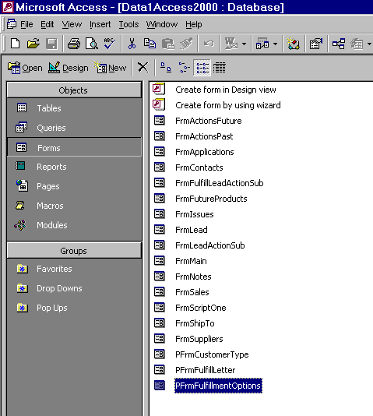
The Tabs - similar to file folder tabs, are now more like folders and now you can create your own folders called “Groups”
This is the main database menu. The tabs allow switching back and forth from tables, queries, forms, reports, macros and modules.

- When you delete a table from Access it continues to hold disk space until it is compacted. Compacting and repairing should be done every week.
- Corrupt databases can be restored by PkSolutions (http://www.pksolutions.com) 1-415-221-4194

Databases: Microsoft Access continued

- Relationships can be created using the relationship editor: Tools, Relationships
- This is what makes the database a “relational” database, many tables are related to each other using some form of “LinkNumber”
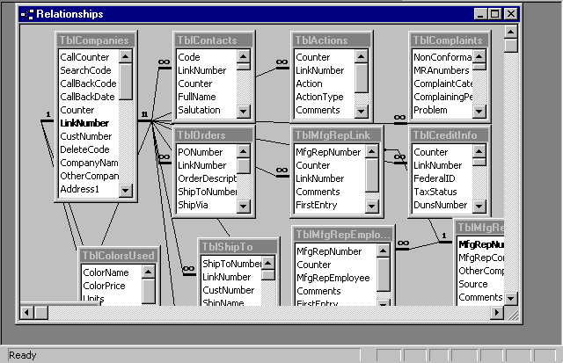
Tables are linked based on the link number
Joins are made with cascading updates and deletes
Many to many relationships are constructed by creating two other relationships...a many to one and then a one to many.
There is a one to many relationship between the companies table and a bunch of other tables.
There are good examples of relationships in the “Order Entry” database which can be created from the New Database Wizard.

Access Shortcuts
- Ctrl+; puts in today’s date.
- Shift + enter saves a record.
- Ctrl+’ duplicates the above field.
- Ctrl+enter allows multiple lines in one field.
- F2 allows editing. Use home or end to get to beginning or end of the field.
- Double clicking in the column header at right sizes the column automatically.
- Default values can be overwritten but go in automatically. Use this to enter repeating data.
- Required fields cannot be null. Validation rule could say “Is Not Null”
- L* gets any record starting with L
- ? is a wild card for one letter
- If a macro is named “Autoexec” it will run when the database is opened. e.g. Open Form
- Ctrl+C copies and Ctrl+V pastes
Databases: Microsoft Access Continued

Queries
- A query is a way to group records and their fields and carry out instructions on the underlying dynaset.
- Queries are not permanent collections unless they are “Make Table” queries.
- There are several types of queries: Select, Make Table, Append, Update, Delete.
- To create a query you must click on the “Query” tab and then click on “New”
- The Query Wizard creates two important queries: “Find Duplicates” and “Find Unmatched Records”. “Find duplicates” will find all records that match in a specific field in a table. This is useful if you have been given a database and you want to check it out for merge/purging

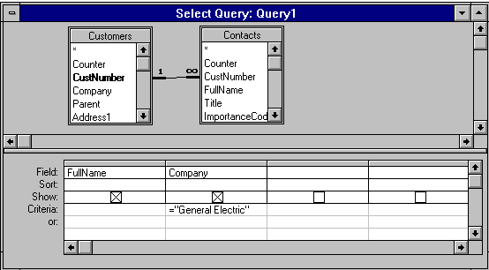
This query will bring up all the contacts (FullName) of all the companies named , exactly, "General Electric"

- Forms and reports can be based on queries and if not too sophisticated will allow editing of the underlying tables. They are run by clicking the “!” button.

Databases: Microsoft Access continued

Queries continued
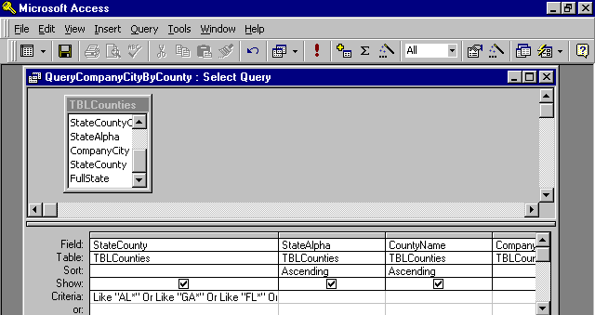
The Run Button
The Ellipses Button
- Criteria can be set by clicking on the “Ellipses” build button while the cursor is in the criteria row under the field of choice.
- A query with a calculation expression that contains a field with a null value (nothing in it) will render the calculation invalid…so make sure you do not have any null values in your data.
- Wildcard characters are defined in Help and include *, ?, #, [ ], !, -, These must be understood.

Frequently used query criteria statements are:
- Like "*string*" which brings up all records with "string" in name. The * is a wild card.
- "Astring" or "Bstring" brings up records with the name equal to Astring or Bstring
- Is Null brings up records with name never entered (empty)
- = "" brings up records that have had a name erased
- > 1/1/2000 brings up records with the date field later than January 1, 2000
- <> 200 is not equal to 200 for a number field and it can be replaced with Not Like for a text field

Parameter Queries
- When you enclose words in square brackets [ ] and put them in the criteria line or the update-to line and run the query it will fill the criteria or update-to with an entry. e.g. [What is the link number?]
- Another example, if you put the following in a query criteria “[Enter the salespersons name]” the query will ask you to “Enter the salesperson’s name” and use whatever you type in as the criteria.

Databases: Microsoft Access continued

Forms
- Forms are used to enter and change data in underlying tables. A form can have one or more fields from one or more tables. If multiple tables are used the form can be based on a query.
- Forms can be automatically created using the “Auto Form” button. Simply highlight the table of interest or query of interest and click on the autoform button.

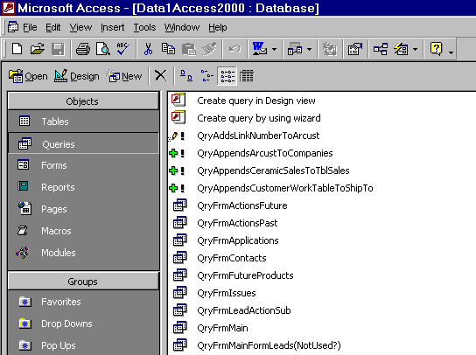
The Auto Form Button

- Once a form is created the fields (controls) and their names can be moved together when you see a hand or by themselves when you see the finger in the form design view. The finger is gotten by placing the arrow on the upper left handle. Use the handle to size the fields also.
- A form with a sub-form can be created by first creating a form for each table and then using the form wizard to create a combined form. This works great for one-to-many relationships because it will show all of the contacts at a company but it will only show the company once.
- The properties window will allow the changing of fonts and more. Click on a field in the form design view and then right-click to bring up the menu box.
- Forms look the best when the fields are lined up left justified and their names are right justified.
- To print one form, click File, Print, Print Selection.

Databases: Microsoft Access continued

Reports
- Reports print out one or more controls/fields from a table; or from several tables based on a query.
- Much of what works for forms also works for reports. There is an Auto Report button just like the Auto Form button shown above. However, this puts all the fields in vertical order rather than across the top of the report as is more desirable.
- Three important selections can be made. Grouping/Sorting; Field Selection; Properties
- Grouping/sorting and the field selection begin with clicking on their Icons in the report design view.
- Properties can be edited by right clicking on the appropriate control/field.

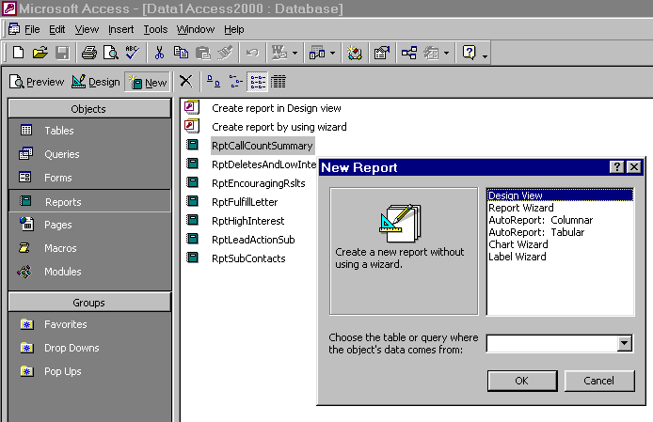
For a new report choose the Report folder and then click New
Once you click New you can choose a Report Wizard and enter your data source here. Use a table or query that already exists

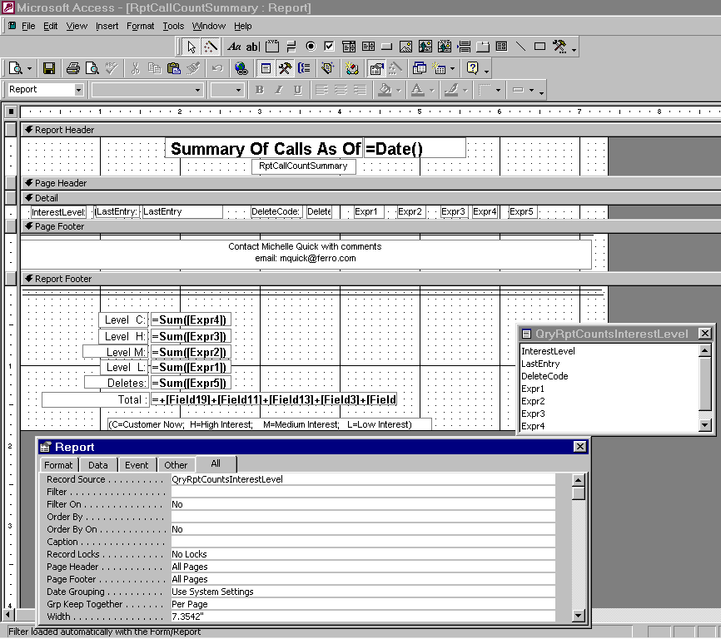
Get the field list from clicking "View, Field List"
The sorting and grouping icon allows you to group and sort your information
Get the property table by clicking in this box

Property table
Databases: Microsoft Access continued

Reports continued
- In the page header section, reports should have a title box that includes the path, database, table/query, grouping/sorting and the report name. Also a date text box (control source = Date() ) should be in the page header. This can be helpful when you must go back and redo the report or make changes to it.
- Page headers should have a 2 point line under the text.
- Group headers should have a 1 point line under the name.
- In the Group footer properties set the “Force New Page After Section” if you want a new group to be started on a separate page.
- Add a control to the report footer that is “=count([fieldname]) to count the total number of occurrences of a particular fieldname.
- Add a control to the page footer that gives the “Page N of M Pages” by clicking on the ellipses for the control source of the text box that you added to the page footer.
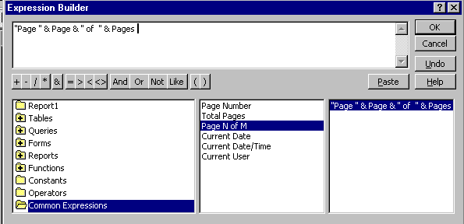
Once you add a text box you can use the control source to designate a common expression, such as “page x of z pages”

The expression builder is brought up by clicking the ellipses icon on the control source line of the property table for the field.

Databases: Microsoft Access continued

Printing Multi-Column Reports
To print a list of data, such as all companies in your database, in columnar format that snakes down the first column and then on to the second column and then on to the next you must do the following:
- Click on Reports tab from the main database window
- Highlight the report you want to have in columnar format
- Click on File, Page Setup
- At the Print Setup dialog box, click on “Columns”
- Set the Number of Columns: and choose the appropriate Column Layout
Enter the number of columns that you want here.

First, click on File, Print, then Setup
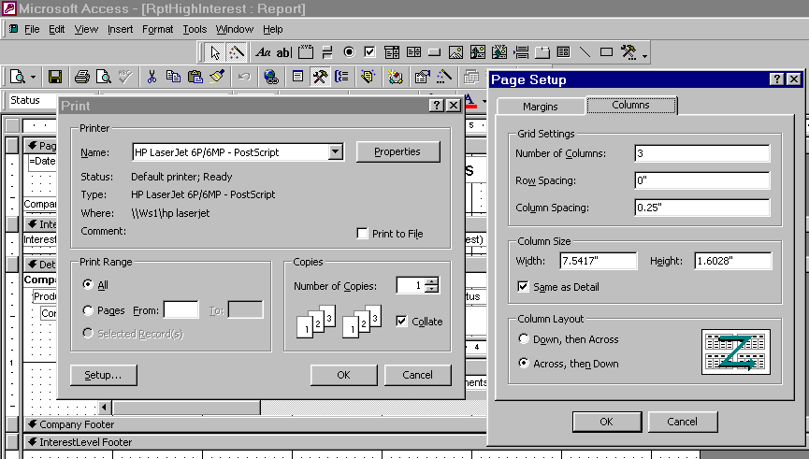
Select Down, then across here if you want the data to go down the 1st column and then start at the top of the second column

Databases: Microsoft Access continued

Mail Labels
- To do mail labels, choose Reports, New, Label Wizard and then choose a query or table with all fields to get items from the Customers table and the Contacts table.
To add the fields to the Prototype label you can click on the field and then click on the arrow to move it into Prototype box.
Chose an Avery label number if you are planning to to use an Avery label. It does not have to an Avery label as long as it is the same size and number of labels across.

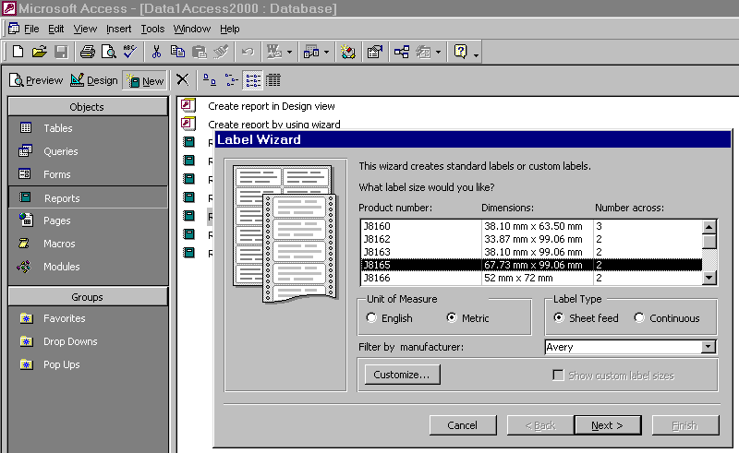
Go to a new line by hitting the enter key. Add commas and spaces as necessary.

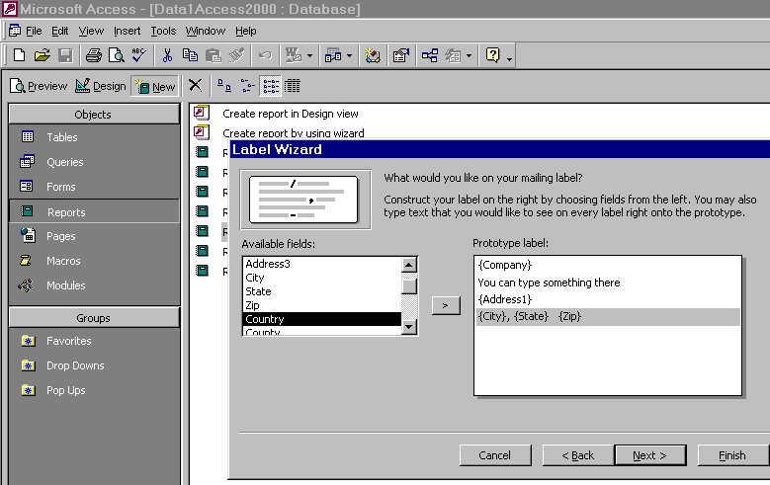

Databases: Microsoft Access continued

Macros
- Macros are pre-defined instructions that the computer carries out when specific events occur. The most common events are “Before Update”, “On Open”, “On Click”, etc.
- The most common macros are “SetValue” or “Open Form” macros. The Set Value macro involves determining the “item” whose value you want to set and the “expression” to set the value to. The “Open Form” macro can be used to open a form that may have a Combo Box with a table attached to it.
- “Last Entry” is a good value to set. The item is the field “LastEntry” and the value is the expression for today’s date ( Date() ). There is no “equal sign” in the expression.

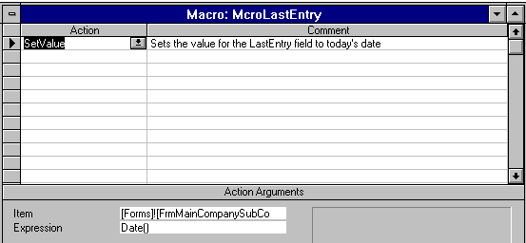
This is the value that you need to set for the date.

- This macro should be set to run at the “Before Update” line in the form properties.

Importing And Exporting Records
- To import records from another application go to the main database menu and choose File, Get External Data, Import and then select the proper data source (format)..... e.g. Excel, dBase, etc. Sometimes it is easier to import data into Excel first and then save it as an .xls file and then import the Excel file into Access.
- It takes less time to link a table to your working database rather than to import it and attaching uses less memory than the memory used when importing.
- To export records you do almost the same thing except select File, Save As/Export and choose the data destination (format). You must have the table you wish to export highlighted.

Databases: Microsoft Access continued

Merge/Purging To Remove Duplicates
When records are imported from another application they should not be appended until they are merge/purged against existing records. The first step is to establish a customer number, such as the letter A plus a counter field.
- The process should be done in two passes. The first is done on phone with area code. The second is done by adding the 1st ten letters of the address along with the city, state and zip into one field.
- A table with the records and these fields is copied, structure only. Then the copied table has the phone number designated as the primary key. Later this will be repeated with the “address” field.
- Next append the existing tables and note that only unique records will be appended.
- Now establish a code field in all tables and in the new table update query a “U” into the code field
- Next update query the “U” from the new table to each of the old tables. Now you know the records without a “U” are to be deleted. These can be evaluated before actual deletion.

Databases: Microsoft Access continued

What You Can Do With Your Database
- Automatically identify who needs classes based on expiration dates or “ContactCode”
- Email letters directly using SnapShot format free from Microsoft
- Create reports that show everyone that completed programs during a period
- Generate Attendee Letters and envelopes with information about their program
- Report on attendees who are scheduled for or completed programs.
- Print a Transcript for attendees to programs
- Print a Graduation Diploma for attendees
- Record information about your customers such as certification expiration dates, birthdays, spouse names, hobbies, children’s names, etc.
- Merge letters and mail labels from Microsoft Word.
- Send faxes automatically by merging records to WinFaxPro.
- Send email automatically by merging records and using Microsoft Outlook.
- Tele-Prospect your database and keep track of the information.
- Record information about all training programs and know who the trainers are and where the classes will be held
- Exchange information with all members of the organization
- Enter elaborate directions on how to get to classes.
- Fill fields automatically with a variety of drop-down selection tables
- Purchase “response” lists from trade magazines or other industry sources and add them to your prospect list.
- Keep company, address, phone, fax information on prospect and customer companies. TblCompanies
- Keep contact name, title, service interest, phone numbers on personnel located at companies. TblContacts
- Maintain descending date order list of planned and completed actions at company. TblActions
- Maintain lengthy notes associated with companies. TblNotes
- Maintain class attendee records. TblContactsClasses
- Maintain class records. DTblClasses

II. Training Database

Tables

Tables starting with “D” are drop down tables and need to be completed with information from your business. Tables starting with “T” are the main data tables.

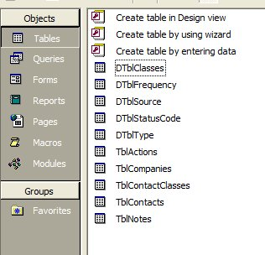

Queries

A Query is used to get information from your. Queries are used to find information for a form or a report. They can also be used to find a specific person, class or company.

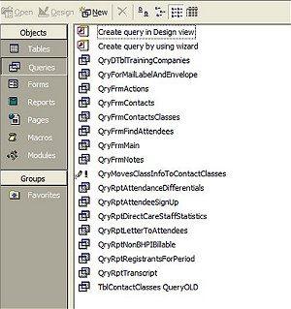
Relationships
This application is a fully relational database with the tables having the following relationships. Note that the TblCompanies is the primary table and that all other tables, except TblContactsClasses, are related to it by the LinkNumber.

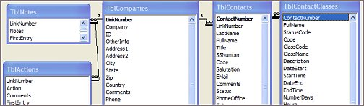

Panel
The Panel is used to navigate to forms and reports. Any object, including forms, reports or queries, in the database can be added to the Panel to make it easy to activate the object.

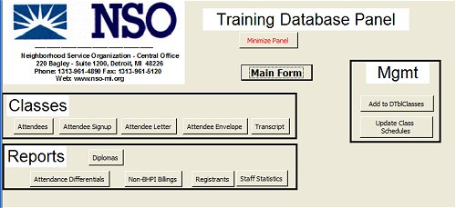

FrmMain with Contacts tab
This is the Main Form with all the tabs and the Contacts tab activated.

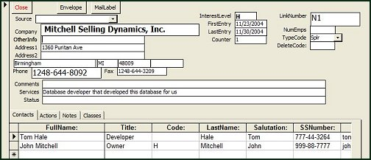
Envelopes and mail labels can be brought up by these buttons

The top portion of this form has information on the companies in the database.
The tabs include Actions, Notes and Classes
FrmMain with Actions tab
This is the Main Form with the Actions tab activated.

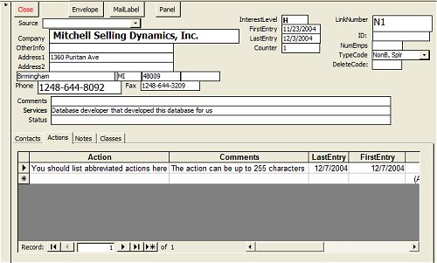
Actions that have been completed or are planned should be recorded here.

FrmMain with Notes tab
This is the Main Form with the Notes tab activated.

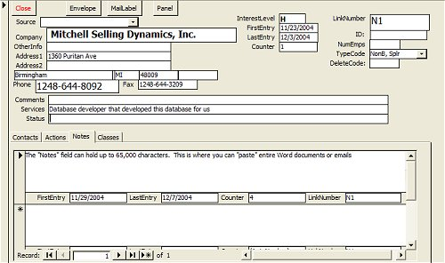
This is where you can cut and paste the contents of Word documents or email for reference purposes. Each note here can be up to 64,000 characters long and you can have as many notes as you want. They are sorted in descending date order so the latest note is in front.

FrmMain with Classes tab
This is the Main Form with the Classes tab activated. The StatusCode is the important field here since it indicates an individual’s StatusCode for a class. It can be C-Completed; F-Failed; NS-No show; PC-Partial Complete; RF-Required Refresher; RN-Required New Employee; S-Scheduled; XX-Class Not Available in DtblClasses. The StatusCode comes from the DTblStatusCodes

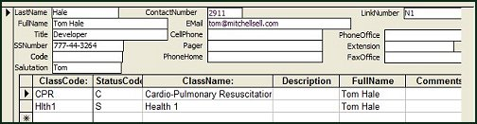

The Classes tab shows some info from the FrmContacts and under that is info on the classes that this specific contact has taken, is scheduled to take, or needs to take.

Classes tab with ClassCode DropDown Open
This is the Classes tab activated with the ClassCode DropDown activated.

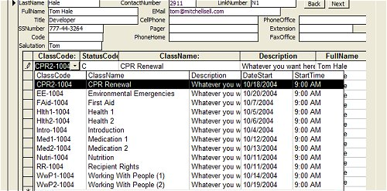
You can navigate back and forth among contacts at the company using the “Back” and “Next” buttons
When you click on the ClassCode in the DtblClasses drop-down, the class information and the contact’s FullName are automatically inserted into the TblContactsClasses
When a ClassCode is selected from the DropDown all information from DtbleClasses will populate the record for the individual.

FrmEnterClasses
Bring this form up from the “AddToDTblClasses button on the Panel. This form is used to added classes to the DTblClasses.

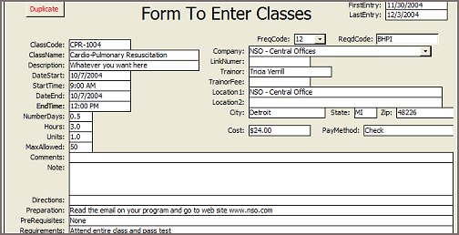
The “ClassCode” must be unique. It is a combination of Alpha characters for the class name plus 6 numeric characters representing the date in MMDDYY format

RptLetterToAttendees
Bring this report up from the Attendee Letter button on the Panel. This is a letter, which could be printed and mailed, faxed or emailed (using Microsoft’s free “SnapShot viewer) to an attendee. There is also an Envelope that goes with it.

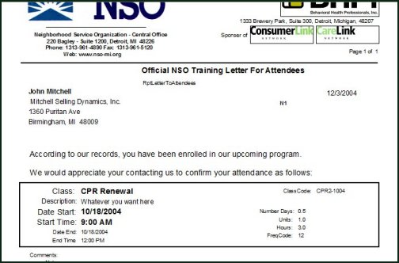
RptLetterToAttendeesEnvelope
Bring this report up from the Attendee Envelope button on the Panel. This is an envelope for the letter, which could be printed and mailed to an attendee.



Identify Individuals Needing Classes
To identify new individuals and individuals requiring classes you must click on the “Update Class Schedules” button on the Panel. This will search the TblContactsClasses for new contacts and check their company’s TypeCode to BHPI=Behavioral Health Professional Inc; Govt=Government; NonB=NonBHPI; NSO-C=NSO Central; NSO-O=NSO Other; Other=Other; Pers=Person; Splr=Supplier; Train=Training Provider

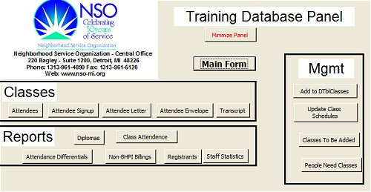
Update Class Schedules Button

RptPeopleNeedClasses
This report can be brought up by clicking on the button “People Need Classes” on the panel
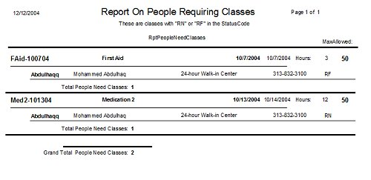
Identify Classes To Be Added
To identify new classes that must be added you must click on the “Update Class Schedules” button on the Panel and then bring up the report RptClassesToBeAdded. Once you hit the Update Class Schedules anyone needing a class that is not scheduled will get the latest scheduled call and the individual will get “XX” in his StatusCode for the class.

Update Class Schedules Button

RptClassesToBeAdded
This report can be brought up by clicking on the button “Classes To Be Added” on the panel

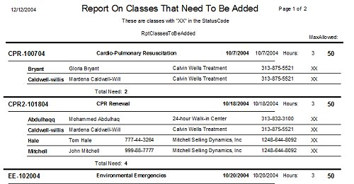

RptTranscript
Bring this report up from the Transcript button on the Panel. This shows all completed classes for an individual for any period in time.

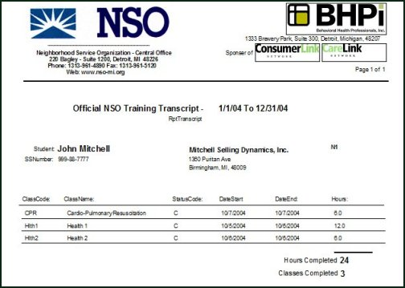

RptRegistrantsFor Period
Bring this report up from the Registrants button on the Panel. This shows the attendees that completed or are scheduled to all programs.

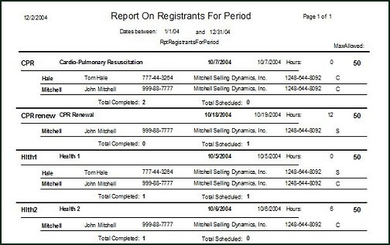

RptAttendanceDifferentials
Bring this report up from the Attendance Differenctials button on the Panel. This shows the attendees that completed or are scheduled to all programs.

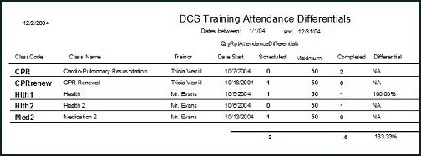

RptStaffStatistics
Bring this report up from the Staff Statistics button on the Panel. This shows the attendees that completed all programs for a given period

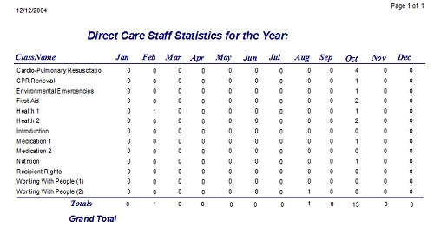

RptDiploma
Bring this report up from the Diploma button on the Panel. This will print program name, attendee and the completion date on a “diploma” form gotten from www.paperdirect.com . The form used in this example is called: Stratton, Maroon/Gray Certificate #28, CT1081; Seal is Certificate Seal Gold 2” 6UP, CT500 PaperDirect phone is 800-A-Papers



