Manufacturers’ Agents

Access Database

John Mitchell


_______________________________________________________________________________________________
1360 Puritan Ave, Birmingham, MI 48009

Phone: 1-248-644-8092
Email: john@mitchellsell.com
Web site: www.mitchellsell.com
Manufacturers’ Agents Access Database

Table Of Contents

SECTION DESCRIPTION PAGE

I. Databases: Microsoft Access................................................................................. 4
Understanding Databases........................................................................... 4
Terms……………….........................................................................…… 4
Principles Of Good Database Design.......................................................... 5
Normalization............................................................................................. 6
Network users…………............................................................................. 6
Field Recommendations.............................................................................. 7
Data Entry Recommendations..................................................................... 8
Access Features.......................................................................................... 9
Relationships ……………………………………………………………. 10
Access Shortcuts........................................................................................ 10
Queries....................................................................................................... 11
Forms ……………................................................................................... 13
Reports ………………………………………………………………… 14
Printing Multi-Column Reports................................................................... 16
Mail Labels................................................................................................. 17
Macros....................................................................................................... 18
Importing And Exporting Records.............................................................. 18
Merge/Purging To Remove Duplicates …………………………………. 19
What You Can Do With Your Database...................................................... 20

- The Customer Database
Tables and Relationships............................................................................ 21
Autoexec Form (Panel)……................................................................…… 22
FrmProducts………………………............................................................ 22
FrmMain with Contacts tab........................................................................ 23
“Quick” button and Form…........................................................................ 23
FrmMain with Actions tab…........................................................................ 24
FrmMain with CallReports tab….................................................................. 24
FrmMain with Notes tab….......................................................................... 24
FrmMain with OtherAddresses tab….......................................................... 25
FrmMain with Discounts tab…..................................................................... 25
FrmMain with Pricing tab…........................................................................ 26
Create a new Price Card……........................................................................ 26
FrmMain with Orders tab…........................................................................ 27
Creating a BackOrder…………………………………………………….. 27
FrmMain with Quotes tab…........................................................................ 28
Inventory Management……........................................................................ 29

Continued……

FrmMain with ReOrders tab….................................................................... 29
Receiving less than you ordered…………………………………………… 29
Reorder Evaluation (Panel Button)……………..………………………… 30
Commissions……………………………………………………………… 31
FrmMain with CrossReferrence tab…......................................................... 31
Fill In Monthly Sales (Panel Button)……….…..………………………… 31
Records with no LinkNumbers................................................................... 32
Monthly Commission Report…………………..………………………… 32

III. Databases: Microsoft Access.................................................................................
Replication and Synchronization................................................................ 33
I. Databases: Microsoft Access

A database program is the most useful application for increasing sales. However, it is the most difficult to master. While word processing programs deal with words and spreadsheet programs deal with numbers, database programs deal with both words and numbers. Normally, it requires taking a series of classes and working with databases for several years to really learn it. However, it can be quite useful in much less than a year. Everything that can be done with a spread sheet program can be done with a database program but the converse is not true... and it can be done faster!

Database programs deal with information in its smallest form and thus can easily group information in any way that is necessary. Spread sheets tend to keep information in groups that cannot be devided as easily as in database programs.

Microsoft Access is among the easiest to learn and is extremely versatile. At this writing Access has over a 50% share of the database programs in the field. Access can manipulate data much quicker than most other programs and can handle very large files easily (up to a gigabyte or 1000 Megs).

A database is a collection of records and each record has fields that contain information. Typical fields include: Company, Address, City, State, Zip, etc. Examples of databases are: Customers; Suppliers; Employees; etc. These would list information on the subject in the form of rows with each field providing the name of a column.
Company
Address
City

Note: A database requires a lot of maintenance and discipline. Most companies will have to establish a database manager who will learn Access and police compliance. We recommend you get started with a company like Mitchell Selling Dynamics, Inc. who can get you up to speed immediately but this will only be the beginning and there will always be a major effort required on your part to keep the data current. Information is POWER and companies will come to depend on the database to get crucial information about their customers but this information source is not free. The data must be entered !!!!!

Terms
Control Name that is used for a field in a table or a field that exists as only an expression.
Database A collection of tables.
Field This is the heading of one column.
Form An arrangement of some or all of the fields that can be used to modify the data.
Expression A command to take action.
Normalization Removing redundancy
Query Queries group the records and execute actions based on instructions.
Record One record represents a row of information arranged in columns.
Report An arrangement of the data that can be grouped and printed but will not allow data modification.
Rushmore Rushmore technology is the engine that runs the queries. Developed by Microsoft FoxPro.
Table A set of records.
Wizard Helpful “Pre-Packaged” instructions that create tables, queries, forms, reports, etc.

Databases: Microsoft Access Continued

Principles Of Good Database Design
Flat files have all information about a subject on one record and the complete database is one set of records. This usually leads to redundancy and requires many updates when something changes. It is often impossible to keep all related files up to date when there is redundancy.

Example:
A flat file customer database has information about the company and sales person included on each customer record. Another database exists in the marketing department with information on the sales person and still another sales person database exists in the HR department. If a sales person moves to another city 3 separate databases must be updated. The better idea is to link these databases together and share common fields so that only one record must be updated.

Relational Databases have inter-related tables sharing common fields which only have to be updated once.
Example:
A relational database might have “LinkNumber” in the Companies table and the same “LinkNumber” in the Contacts table and still another link to the Employee table. Two of the three tables are related by the “LinkNumber” and two are related by the “FullName”. The only redundant information would be the linking field.

Companies Table Contacts Table

LinkNumber
Company
Address
Salesperson
LinkNumber
FullName
Title

Employee Table
FullName
EmployeeNumber
Title

Databases: Microsoft Access continued

Normalization
Relationships can be defined as “one to one” or “one to many”. A one to one relationship exists between a customer and the customer’s dollar value potential. A one to many relationship exists between a customer and the contacts we have for that customer. We do not want to have any “one to many” relationships in a table. This is called normalization. These “one to many” relationships should be established in separate tables linked together with a common field. There are five degrees of normalization all designed to eliminate redundancy.

Example:
A relational database for a company’s customers might have three related tables. These tables are linked by the customer number. Often, a customer number may already exist and therefore we establish a new linking number and we call it “LinkNumber”
Customer Info Contact Info Distributor Info
Customer number Customer number Customer number
Company name Full name Distributor number
Address Title Importance Code
Potential Importance Code Distributor sales person
Sales person number Source of contact Sales in January
Etc. Etc. Etc.

Network Users
These databases have everything (the data tables and the forms) all in the same database. When a database is going to be used on a network with simultaneous users the database should be broken into two databases, one with the data tables and the other with everything else. The forms database will use File, Get External Data, Link to link to the data tables database.

Each user would get a copy of the forms database and they would all link to the data tables database.

Databases: Microsoft Access continued

Field Recommendations
- Longer fields make queries very time consuming.
- Fields over 40 characters in length may not fit on a standard “long” mail label which is 4” wide. We believe 40 characters is long enough for most items.
- Limit field names to unique first 10 characters since field names over 10 characters in length cannot be imported into many programs.
- Do not put any spaces in field names. Other programs cannot deal with this.
- Company names, address1 and address 2 should be 30 characters in length.
- Cities should be 20 in length
- Use a contact’s full name as a field. Breaking a name down into firstname, lastname, initials, suffix-MD/Ph.D. and prefix-Dr/Mr adds to complexity and reduces efficiency. Full name field length should be 25 characters. However, this precludes using a “Dear John:” salutation.
- Titles are good to have although they are rarely used in mailings due to the necessity to abbreviate so many of them. For example, Director Of North American Widget Marketing And Sales would always need to be abbreviated. Make it 15 characters and use it for information.
- Counties (about 3200 in the USA) should be included since they do not change whereas Zip Codes change on a regular basis. County length should be 20 characters.
- A comments field (length of 254 characters) should be included in every table. This can be used to record information varying in nature.
- Having different zip codes for a street address and a mail address (PO Box) can be handled in the address 1 and address 2 fields by using address 1 for the street address with the zip code in parentheses and putting the mailing address (PO Box) in address 2 with its zip code as the primary zip code for the record.
- Customer numbers made up of alpha characters from the customer’s company name can help to indicate a problem in relational tables. e.g. the customer number for ABC Manufacturing could be “abcmfg” which is more meaningful than “195963” and can confirm contacts in the contacts table. Using the customer number as a primary key will prevent duplicates.
- Use a counter to number all the records.
- Separate the area code from the phone and fax. Area codes change from time to time..
- Keep county and country near each other so that they are not switched.
- Zip field should be 10 characters in case the Zip4 comes along by mistake.
- Phone and fax should be 12 in length in case the area code and the dashes come along. The field should be a text field so it supports the “dashes” (-)
- Put all dollar figures in dollars with no decimal places if possible
- Put no or few calculated fields into the database. They can be added to reports or forms.
- Merge/Purges can be done first, on the area code plus the phone number and then on the first 10 letters of the address with the Zip code added to it. Using only the first 10 letters of the address usually eliminates the problem associated with suffixes such as Ave/Avenue, Rd/Road, SW/Southwest, etc.
- Last Entry and First Entry are also good fields to have. The First Entry can be set by a default value in the table/field properties and the Last Entry can be set with a macro that creates a set value routine for today’s date.
- Memo fields can have multiple lines in them by changing the field property for “Enter Key Behavior” to New Line in Field

Databases: Microsoft Access continued

Data Entry Recommendations
- Information should be entered in lower case with the first letter of certain words typed in upper case. This makes the information easier to read and is better for merging to letters.
- Pop up tables (non-editable combo boxes) showing key information should be used to enter important data such as “sales persons number” or “distributor number”. This will reduce errors.
- Data entry personnel should be advised that accuracy is much more important than speed.
- Good workstations are important to prevent fatigue and injury.
- Great lighting with no glare is a must. Light fixtures should have parabolic defusers with a half-inch by half-inch square grid pattern. Monitor screens should be at 90+ degrees to windows. Floors and walls should have low reflectance.
- Get a great chair. The Posturetech II from Office Depot is the best @ $300. The Chair is made by Global International, 560 Supertest Rd, Downsview, Ontario, Canada, M3J-2M6. Your backbone should be parallel to your lower legs and your upper legs should be parallel to the floor. Your knees should be at 90 degrees. Floor to seat height should be 16 to 19 inches.
- Glare/Shield filters should be put over monitors to protect eyes. ELF/VLF E-field radiation should be stopped. Monitor height should be at or slightly below your eye level and about 16 to 22 inches away from your eyes. The line of sight should be 10 to 20 degrees below horizontal. These Glare/Shield filters cost about $50.00
- Key boards should be at elbow height to avoid bending wrists which can cause the repetitive strain injury know as Carpal Tunnel Syndrome. Elbows should be at 90 degrees. During typing movement should come at your shoulders and elbows and not at your wrists. Keyboard should be at 0 to 25 degree angle, about 23 to 28 inches from the floor. Mouse movement should not require a bend in the wrist.
- Relax your hands and wrists once per hour by stretching, rotating and shaking them.
- Noise level can be reduced through sound absorbing fabric materials on the ceiling, walls and flooring.

Databases: Microsoft Access continued

Access Features
- Tables can be created using the table wizards: Table, New, Table Wizards
- Formatting changes the display but not the data. Therefore a number field can be formatted as currency or the field can be made currency.
- The database can be opened in the exclusive or shared mode. Exclusive is best for deletions. This can be changed by going to Tools, Options, Multi-user.

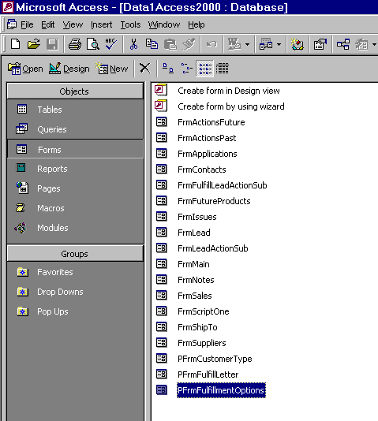
The Tabs - similar to file folder tabs, are now more like folders and now you can create your own folders called “Groups”
This is the main database menu. The tabs allow switching back and forth from tables, queries, forms, reports, macros and modules.

- When you delete a table from Access it continues to hold disk space until it is compacted. Compacting and repairing should be done every week.
- Corrupt databases can be restored by PkSolutions (http://www.pksolutions.com) 1-415-221-4194

Databases: Microsoft Access continued

- Relationships can be created using the relationship editor: Tools, Relationships
- This is what makes the database a “relational” database, many tables are related to each other using some form of “LinkNumber”
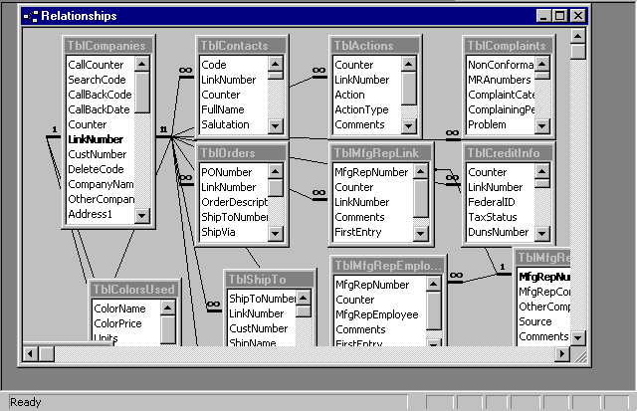
Tables are linked based on the link number
Joins are made with cascading updates and deletes
Many to many relationships are constructed by creating two other relationships...a many to one and then a one to many.
There is a one to many relationship between the companies table and a bunch of other tables.

There are good examples of relationships in the “Order Entry” database which can be created from the New Database Wizard.

Access Shortcuts
- Ctrl+; puts in today’s date.
- Shift + enter saves a record.
- Ctrl+’ duplicates the above field.
- Ctrl+enter allows multiple lines in one field.
- F2 allows editing. Use home or end to get to beginning or end of the field.
- Double clicking in the column header at right sizes the column automatically.
- Default values can be overwritten but go in automatically. Use this to enter repeating data.
- Required fields cannot be null. Validation rule could say “Is Not Null”
- L* gets any record starting with L
- ? is a wild card for one letter
- If a macro is named “Autoexec” it will run when the database is opened. e.g. Open Form
- Ctrl+C copies and Ctrl+V pastes
Databases: Microsoft Access Continued

Queries
- A query is a way to group records and their fields and carry out instructions on the underlying dynaset.
- Queries are not permanent collections unless they are “Make Table” queries.
- There are several types of queries: Select, Make Table, Append, Update, Delete.
- To create a query you must click on the “Query” tab and then click on “New”
- The Query Wizard creates two important queries: “Find Duplicates” and “Find Unmatched Records”. “Find duplicates” will find all records that match in a specific field in a table. This is useful if you have been given a database and you want to check it out for merge/purging

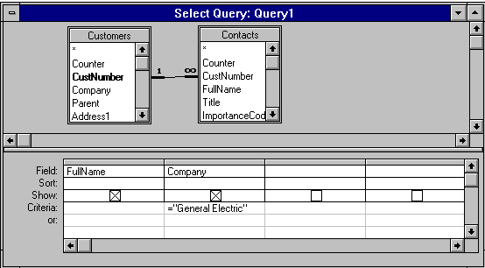
This query will bring up all the contacts (FullName) of all the companies named , exactly, "General Electric"

- Forms and reports can be based on queries and if not too sophisticated will allow editing of the underlying tables. They are run by clicking the “!” button.

Databases: Microsoft Access continued

Queries continued

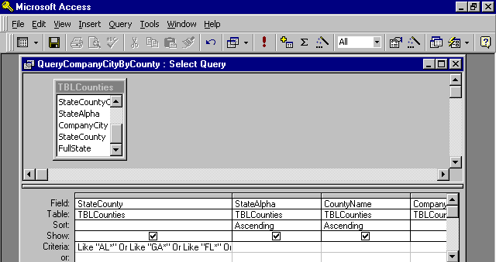
The Run Button
The Ellipses Button

- Criteria can be set by clicking on the “Ellipses” build button while the cursor is in the criteria row under the field of choice.
- A query with a calculation expression that contains a field with a null value (nothing in it) will render the calculation invalid…so make sure you do not have any null values in your data.
- Wildcard characters are defined in Help and include *, ?, #, [ ], !, -, These must be understood.

Frequently used query criteria statements are:
- Like "*string*" which brings up all records with "string" in name. The * is a wild card.
- "Astring" or "Bstring" brings up records with the name equal to Astring or Bstring
- Is Null brings up records with name never entered (empty)
- = "" brings up records that have had a name erased
- > 1/1/2000 brings up records with the date field later than January 1, 2000
- <> 200 is not equal to 200 for a number field and it can be replaced with Not Like for a text field

Parameter Queries
- When you enclose words in square brackets [ ] and put them in the criteria line or the update-to line and run the query it will fill the criteria or update-to with an entry. e.g. [What is the link number?]
- Another example, if you put the following in a query criteria “[Enter the salespersons name]” the query will ask you to “Enter the salesperson’s name” and use whatever you type in as the criteria.

Databases: Microsoft Access continued

Forms
- Forms are used to enter and change data in underlying tables. A form can have one or more fields from one or more tables. If multiple tables are used the form can be based on a query.
- Forms can be automatically created using the “Auto Form” button. Simply highlight the table of interest or query of interest and click on the autoform button.

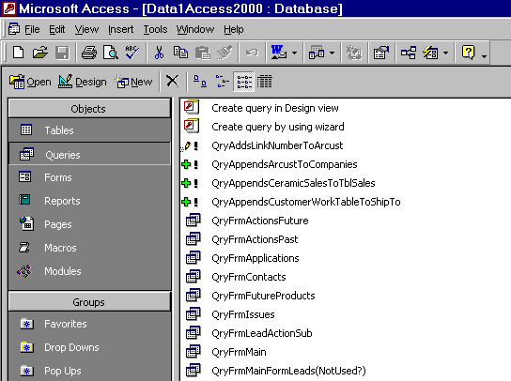
The Auto Form Button

- Once a form is created the fields (controls) and their names can be moved together when you see a hand or by themselves when you see the finger in the form design view. The finger is gotten by placing the arrow on the upper left handle. Use the handle to size the fields also.
- A form with a sub-form can be created by first creating a form for each table and then using the form wizard to create a combined form. This works great for one-to-many relationships because it will show all of the contacts at a company but it will only show the company once.
- The properties window will allow the changing of fonts and more. Click on a field in the form design view and then right-click to bring up the menu box.
- Forms look the best when the fields are lined up left justified and their names are right justified.
- To print one form, click File, Print, Print Selection.

Databases: Microsoft Access continued

Reports
- Reports print out one or more controls/fields from a table; or from several tables based on a query.
- Much of what works for forms also works for reports. There is an Auto Report button just like the Auto Form button shown above. However, this puts all the fields in vertical order rather than across the top of the report as is more desirable.
- Three important selections can be made. Grouping/Sorting; Field Selection; Properties
- Grouping/sorting and the field selection begin with clicking on their Icons in the report design view.
- Properties can be edited by right clicking on the appropriate control/field.

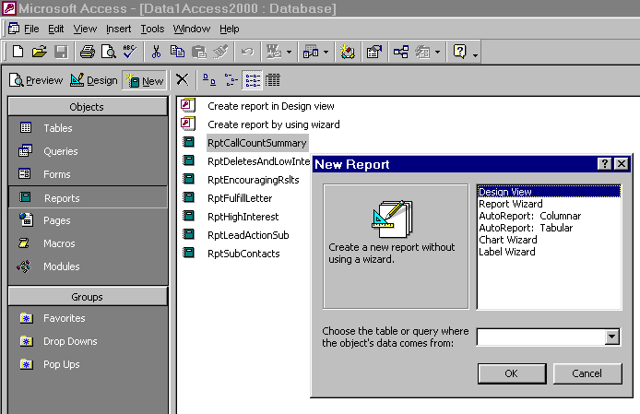
For a new report choose the Report folder and then click New
Once you click New you can choose a Report Wizard and enter your data source here. Use a table or query that already exists

Get the field list from clicking "View, Field List"
The sorting and grouping icon allows you to group and sort your information
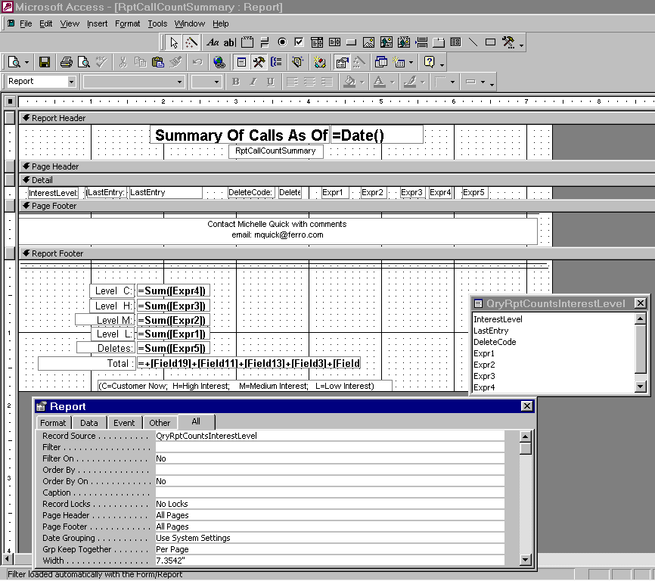
Get the property table by clicking in this box

Property table
Databases: Microsoft Access continued

Reports continued
- In the page header section, reports should have a title box that includes the path, database, table/query, grouping/sorting and the report name. Also a date text box (control source = Date() ) should be in the page header. This can be helpful when you must go back and redo the report or make changes to it.
- Page headers should have a 2 point line under the text.
- Group headers should have a 1 point line under the name.
- In the Group footer properties set the “Force New Page After Section” if you want a new group to be started on a separate page.
- Add a control to the report footer that is “=count([fieldname]) to count the total number of occurrences of a particular fieldname.
- Add a control to the page footer that gives the “Page N of M Pages” by clicking on the ellipses for the control source of the text box that you added to the page footer.
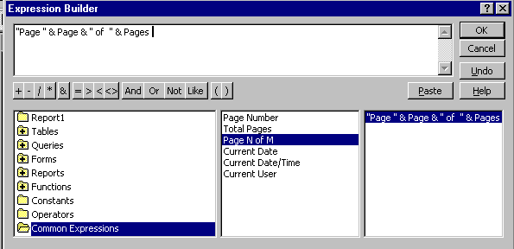
Once you add a text box you can use the control source to designate a common expression, such as “page x of z pages”

The expression builder is brought up by clicking the ellipses icon on the control source line of the property table for the field.

Databases: Microsoft Access continued

Printing Multi-Column Reports
To print a list of data, such as all companies in your database, in columnar format that snakes down the first column and then on to the second column and then on to the next you must do the following:
- Click on Reports tab from the main database window
- Highlight the report you want to have in columnar format
- Click on File, Page Setup
- At the Print Setup dialog box, click on “Columns”
- Set the Number of Columns: and choose the appropriate Column Layout
Enter the number of columns that you want here.

First, click on File, Print, then Setup
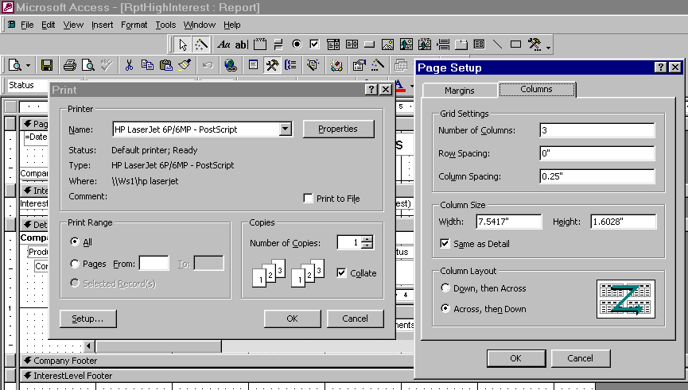
Select Down, then across here if you want the data to go down the 1st column and then start at the top of the second column

Databases: Microsoft Access continued

Mail Labels
- To do mail labels, choose Reports, New, Label Wizard and then choose a query or table with all fields to get items from the Customers table and the Contacts table.
To add the fields to the Prototype label you can click on the field and then click on the arrow to move it into Prototype box.
Chose an Avery label number if you are planning to to use an Avery label. It does not have to an Avery label as long as it is the same size and number of labels across.

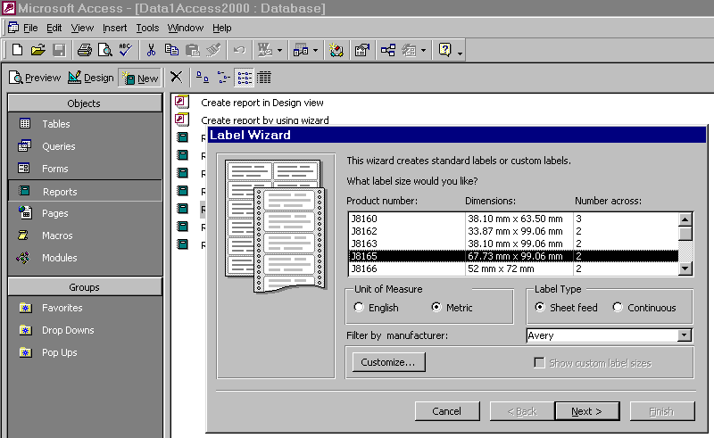
Go to a new line by hitting the enter key. Add commas and spaces as necessary.

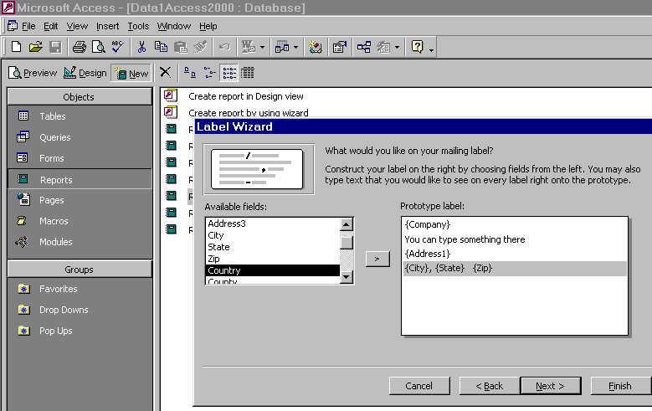

Databases: Microsoft Access continued

Macros
- Macros are pre-defined instructions that the computer carries out when specific events occur. The most common events are “Before Update”, “On Open”, “On Click”, etc.
- The most common macros are “SetValue” or “Open Form” macros. The Set Value macro involves determining the “item” whose value you want to set and the “expression” to set the value to. The “Open Form” macro can be used to open a form that may have a Combo Box with a table attached to it.
- “Last Entry” is a good value to set. The item is the field “LastEntry” and the value is the expression for today’s date ( Date() ). There is no “equal sign” in the expression.

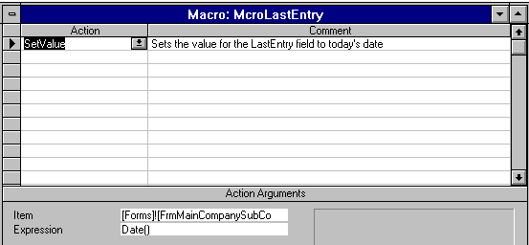
This is the value that you need to set for the date.

- This macro should be set to run at the “Before Update” line in the form properties.

Importing And Exporting Records
- To import records from another application go to the main database menu and choose File, Get External Data, Import and then select the proper data source (format)..... e.g. Excel, dBase, etc. Sometimes it is easier to import data into Excel first and then save it as an .xls file and then import the Excel file into Access.
- It takes less time to link a table to your working database rather than to import it and attaching uses less memory than the memory used when importing.
- To export records you do almost the same thing except select File, Save As/Export and choose the data destination (format). You must have the table you wish to export highlighted.

Databases: Microsoft Access continued

Merge/Purging To Remove Duplicates
When records are imported from another application they should not be appended until they are merge/purged against existing records. The first step is to establish a customer number, such as the letter A plus a counter field.
- The process should be done in two passes. The first is done on phone with area code. The second is done by adding the 1st ten letters of the address along with the city, state and zip into one field.
- A table with the records and these fields is copied, structure only. Then the copied table has the phone number designated as the primary key. Later this will be repeated with the “address” field.
- Next append the existing tables and note that only unique records will be appended.
- Now establish a code field in all tables and in the new table update query a “U” into the code field
- Next update query the “U” from the new table to each of the old tables. Now you know the records without a “U” are to be deleted. These can be evaluated before actual deletion.

Databases: Microsoft Access continued

What You Can Do With Your Databases
- Merge letters and mail labels from Microsoft Word.
- Send faxes automatically by merging records to WinFaxPro.
- Send email automatically by merging records and using Outlook.
- Record information about your customers such as contract expiration dates, birthdays, spouse names, hobbies, children’s names, etc.
- Estimate territory potential by summarizing your database.
- Purchase “response” lists from trade magazines or other industry sources and add them to your prospect list.
- Tele-Prospect your database and keep track of the information.
- Maintain an expense record and print out expense accounts or download to Excel.
- Record time spent at accounts and assign the time to specific activities.
- Exchange information with your headquarters to allow them to do mailings.
- Display pictures/video of your products in action. Digital cameras can take pictures that can be imported into Word and copied/pasted into your database.
- Enter elaborate directions on how to get to accounts along with maps.
- Keep company, address, phone, fax information on prospect and customer companies. TblCompanies
- Keep contact name, title, product interest, phone numbers on personnel located at companies. TblContacts
- Maintain descending date order list of planned and completed actions at company. TblActions
- Maintain lengthy notes associated with companies. TblNotes
- Maintain call reports associated with companies. TblCallReports
- Track quotes to companies. TblQuotes and TblQuoteItems
- Track sales to companies. TblSales
- Track orders and order items and note reasons for lost orders. TblOrders and TblOrderItems
- Track lost orders. TblLostOrders
- Store complaint information. TblComplaints
- Manage leads and lead fulfillment. TblLeads and TblLeadItems
- Store list of competitors with their share and products sold to accounts. TblCompetitors
- Keep info on warranty work and equipment sold to accounts. TblEquipSold
- Track applications of your products by customer. TblApplications
- Maintain credit info on accounts. TblCreditInfo
- Keep pricing and discount info. TblPricing
- Maintain list of ship-to locations. TblShipTos
- Identify your employees associated with each account. TblEmployees
- Maintain list of authorized territories for your distributors. TblCounties
- Track distributors that the company buys from. TblDistributors
- Identify SIC codes for the prospect. TblSic

II. Customer Database

Tables

Tables starting with “D” are drop down tables and need to be completed with information from your business. Tables starting with “T” are the main data tables. TblProducts also has to be populated with information from your business.

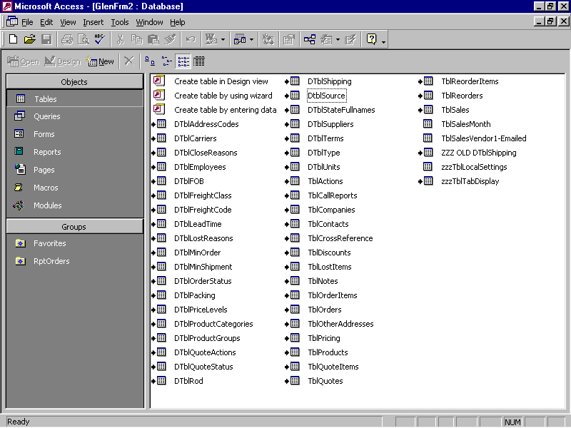

Relationships
This application is a fully relational database with the tables having the following relationships. Note that the TblCompanies is the primary table and that all other tables, except TblProducts and TblLostItems, are related to it by the LinkNumber.

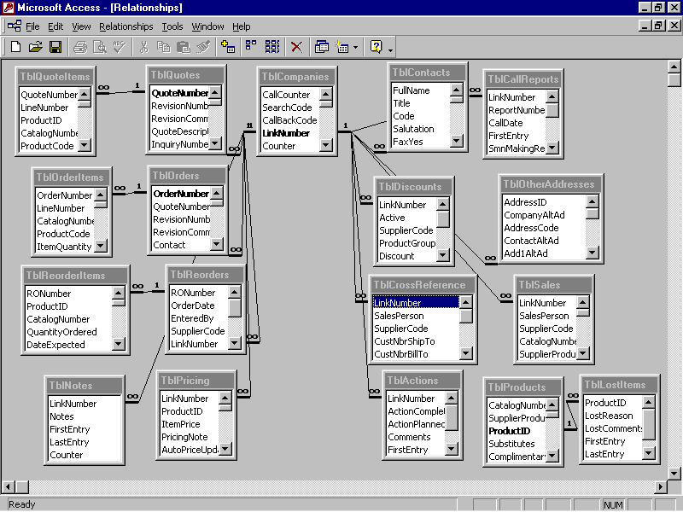
TblLostItems is where we record information about sales we lost due to price, stock or whatever.
Customer Database continued

Autoexec Form
This is the first form that comes up. It is auto-executed when you open your database.

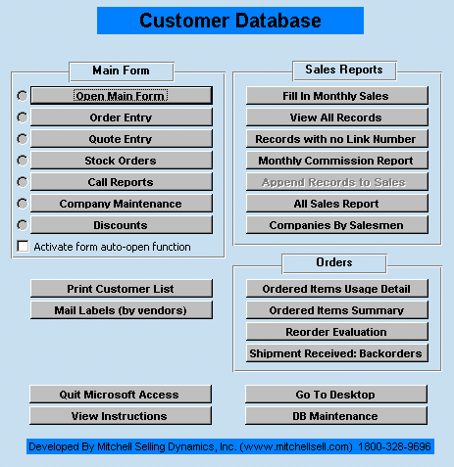
These buttons allow you to bring up smaller, faster forms with only the information you need to do a job.

The Main Form has everything
These buttons are for doing the commissions each month.
These buttons are for managing inventory.
The DB Maintenance button is to:
- Add products to the TblProducts
- Compact the database
- Add or remove tabs from Main Form views.

FrmProducts
This is the form that must be used to add products. Generally, we should not delete products… but we can make them “Inactive” by putting “IN” in the status field. To open this go to the Panel, DB Maintenance and then click on “Add a Product”
These are the list prices for the items. You can have one main price and up to nine other prices.

The customer’s price will be calculated from these prices and can be equal to any of them or use one plus an additional discount.

PriceLevelCom can be shown or not shown on order.
These fields define each product. Once the supplier code is entered several fields are “auto-filled” from info in the DtblSuppliers.
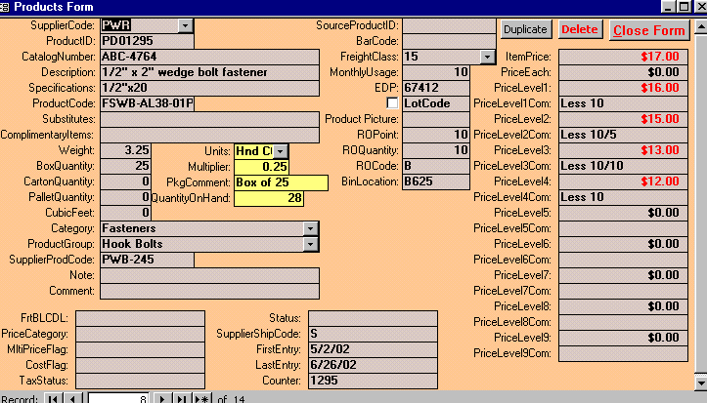
Note the substitutes and complimentary items. These will help increase sales.
“Product Group” is needed for pricing
If the item has more than 1 Piece, the “Units”, “Multiplier” and “PkgComment” fields are very important. “Units” is how they are sold, e.g. “Hundred Count”. “Multiplier” is the number that is multiplied by the pieces to get the pieces in one unit into the “Units”. For example, if the item has 25 pieces and the units are “Hundred Count” then the multiplier is 0.25
Customer Database continued

FrmMain with Contacts tab
This is the Main Form with all the tabs and the Contacts tab activated. It is the slowest form since everything must load before it can be used.
You can view all TblProducts information by supplier or for all products by clicking on “Products”.

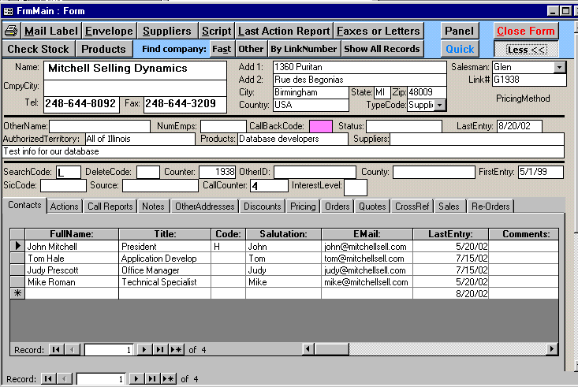
Note the “Less” button to reduce the amount of info you see.
Use “Check Stock” to check the availability of any item. It will show the “Quantity On Hand”, “Quantity On Reorder” and the “Committed Stock”. It also provides a place to enter “Lost Orders”.
This is the contacts tab with info about each person at the account. You can scroll to more info about them.
These are for navigating between company records.
These are for navigating between contact records and you can scroll to see more.

FrmMain with “Quick” activated
This form allows you to quickly check net price and availability for any account. You can make selected items become an Order by clicking on the “Create Order” button at the bottom.

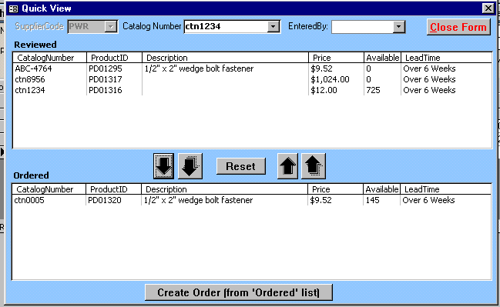
First you must enter the supplier code
Then double click on an item to choose it from the Catalog Number dropdown.

This will provide customer specific pricing and availability
You can list several items in the top section so you can discuss them with your customer and then move all or several to the bottom to be made into an order.
Items can be moved up or down by highlighting them and then clicking on the appropriate arrow.

Customer Database continued

FrmMain with Actions tab
This is the Main Form with the Actions tab activated.

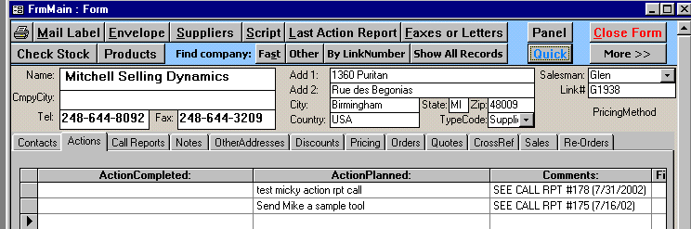
Sales actions that have been completed or are planned should be recorded here.

FrmMain with Call Reports tab
This is the Main Form with the Call Reports tab activated.

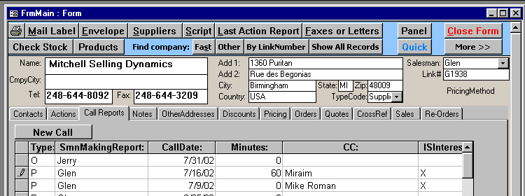
Meetings with customers by sales people should be recorded here. Use the “New Call” button to enter a new record

FrmMain with Notes tab
This is the Main Form with the Notes tab activated.

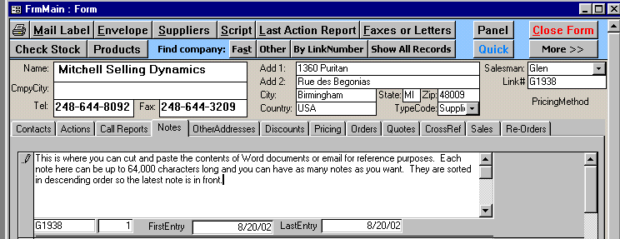
This is where you can cut and paste the contents of Word documents or email for reference purposes. Each note here can be up to 64,000 characters long and you can have as many notes as you want. They are sorted in descending order so the latest note is in front.

Customer Database continued

FrmMain with OtherAddresses tab
This is the Main Form with the Other Addresses tab activated.
Bill-To; Ship-To or Mail-To addresses are entered here if they are different than the address show for the main record. You enter the “BT” or “ST” “AddressCode” as appropriate. The computer will automatically assign them an “AddressID” which can be chosen when creating a Quote or an Order.
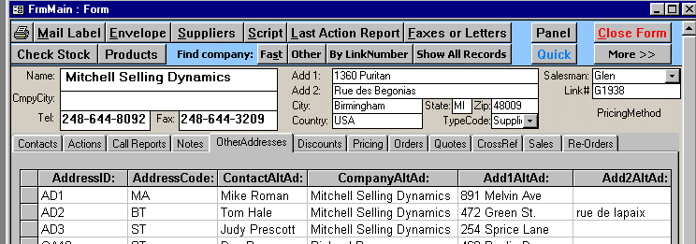

FrmMain with Discounts tab
This is the Main Form with the Discounts tab activated. This is where you enter SupplierCode and ProductGroup that the account will be buying along with the appropriate price level and discount.
Label is checked when you want this account to view the PriceLevelCom statements in TblProducts.
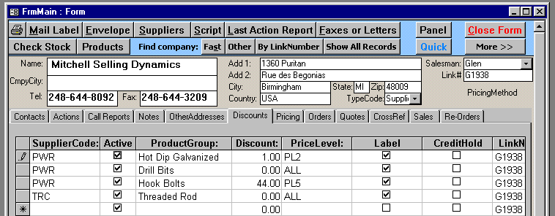
SupplierCode and ProductGroup
Active is checked when ProductGroup can be purchased by this account

PriceLevel and Discount entries define pricing by ProductGroup for this account. You can give this account any of the nine price levels for the Product Group plus you can give him an additional discount. Or on Quotes you can show all price levels by entering ALL.

Customer Database continued

FrmMain with Pricing tab
This is the Main Form with the Pricing tab activated. This is where you store each item that you will sell to the account along with notes about the pricing. This will insure that you have consistent pricing for each item by account. The system allows you to manually change a price on a product and know why you changed it. The pricing cards can be auto-updated when a price increase occurs.

If pricing for an item is manually altered a red “M” will appear on the item and on the account by the field “PricingMethod”.

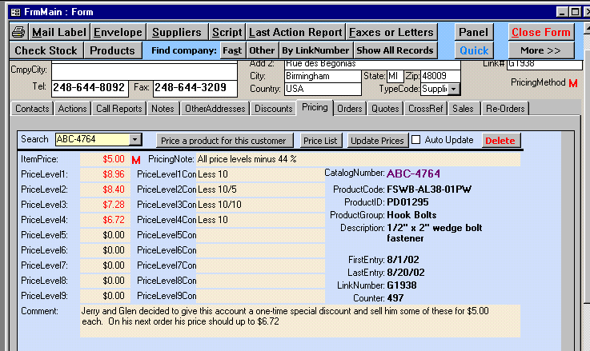
If an item is manually altered a red “M” will appear on the item and the account.
A note on the price levels is put in this field to remind you of the what you entered in the TblDiscounts for the ProductGroup for this account.
You can enter your own comments about the price for this item for this account.
The PriceLevel and the PriceLevelCom fields are populated from the TblProducts and the TblDiscounts. The proper price for this account is shown in this “Price Card” and can be modified manually if necessary. Non-zero numbers are shown in red.

Create a new price card
You can create a new price card from the Pricing tab or you can use the Quick form. On the Quick form, a pricing card will be created if you hit the “Create Order” button at the bottom and the item did not have a previous price card.
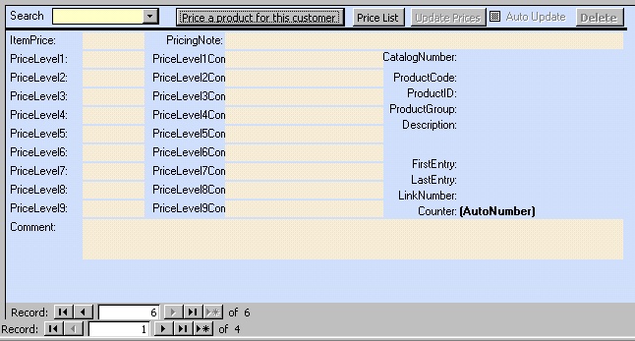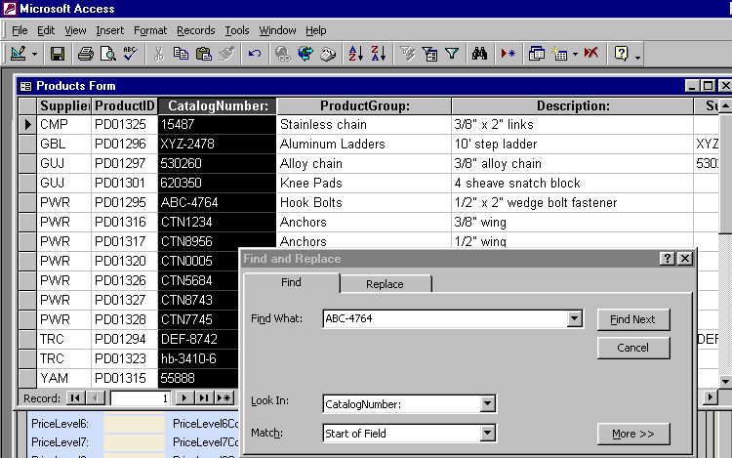
First hit the new record symbol and then click on the “Price A Product” button.
When the list of products comes up you can click on a column and then sort it using the “AZ” button then click on the binoculars to find your catalog number. Once you have your item double-click on it.

Customer Database continued

FrmMain with Orders tab
This is the Main Form with the Orders tab activated. This is one place for you to enter an order. The other place is using the “Quick” button.

There are three sections. The top section is the Order. The next section is the OrderItems and the bottom section is an un-editable datasheet view of the order items for viewing only.
First, you must enter the SupplierCode. Then click on “Add Item From Pricing”
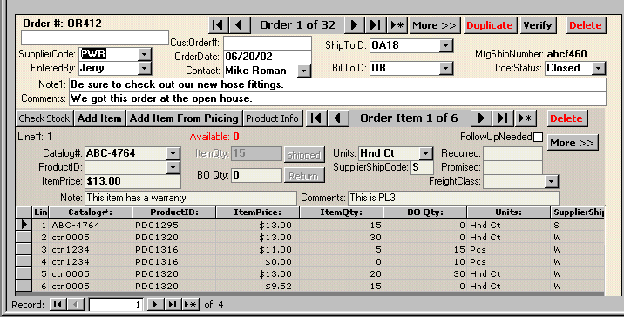
You can navigate through the orders here.
You can click the “More” buttons to see more info.
Check Stock and Product info allows you to look at availability and other info on this item.
Product Info will show you all item info.
When the item is shipped you must click on the “Shipped” button on each item This will reduce the Quantity-On-Hand.

Creating a BackOrder
When you enter an order for more than the available quantity a “LOW STOCK” warning will appear telling you that a BackOrder will NOT be created if the SupplierShipCode=”S”.

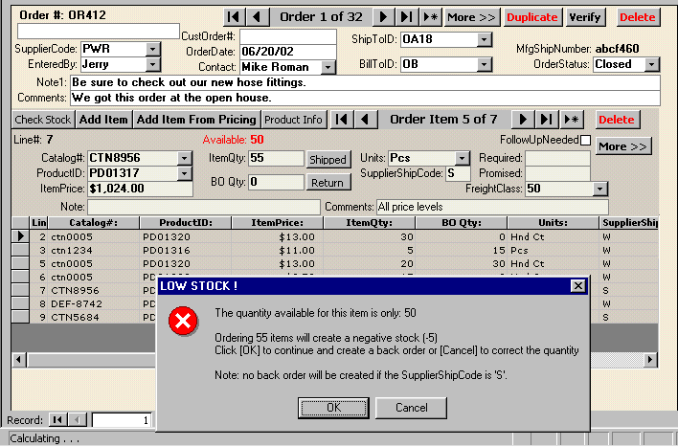
When a BackOrder is created the BackOrder number will be the same number OrderNumber as on the original order plus BO-01 for the first BO.
Customer Database continued

FrmMain with Quotes tab
This is the Main Form with the Quotes tab activated. This is where you can create a quotation for a customer using one price or several prices (based on order quantity for example).

There are three sections. The top section is the Quote. The next section is the QuoteItems and the bottom section is an un-editable datasheet view of the quote items for viewing only.

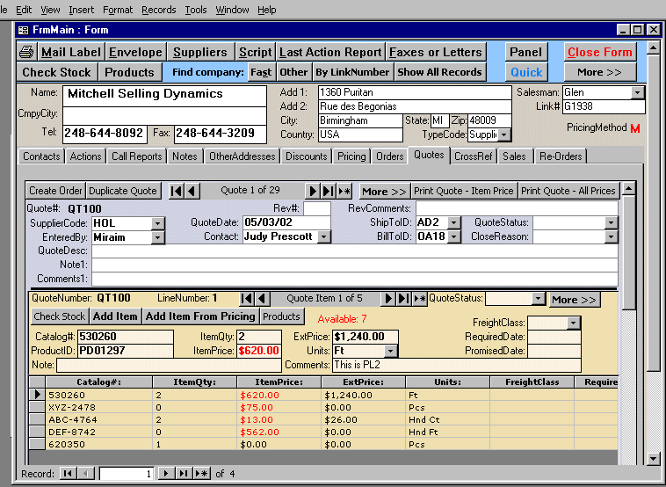
First enter the SupplierCode and then your name.
If the account decides to order some of the items, you must go into each item and click “Ordered” and then you can click “Create Order”
You can choose to have a different Ship-To or Bill-To address.
The note field prints on the quote and the comments are for internal use.
You can print a quote with just one price (accounts item price) or all prices.

When you get into the Quote Items you should first “Add Item From Pricing”. This gives you a shorter list. Then if you don’t have the item you need hit the button “Add Item”
The quote status should be completed so you know why you lost business.

Customer Database continued

Inventory Management

FrmMain with Reorders tab
This is the Main Form with the Reorders tab activated. To view this form you must be on an account that is one of your suppliers and has “Supplier” in the TypeCode field.
We have set up for up to three deliveries as can be seen by InTransit1 to 3. If you have an expected delivery date you can enter it.
If you receive less than you ordered, InTransitQty2 will be filled with remaining quantity.
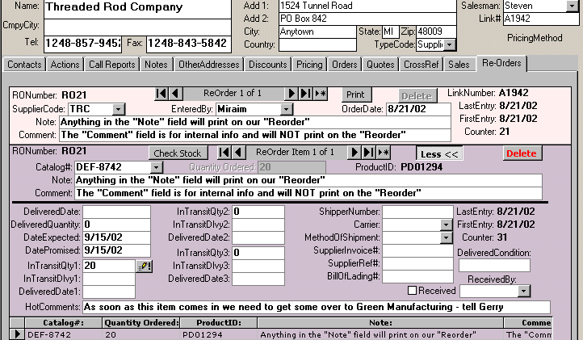
When you receive delivery you should click on this icon. This will update the QtyOnHand.

Receiving Less Than What You Ordered

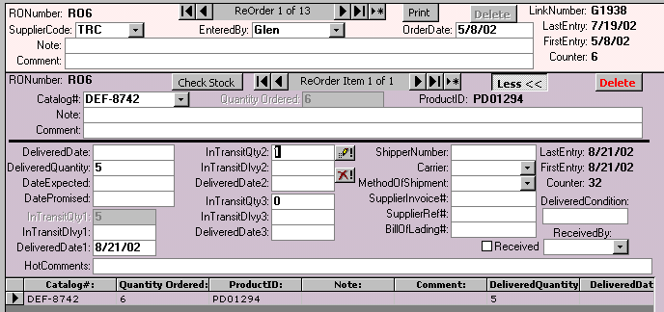
When you receive less than your order quantity and click the icon you will see InTransitQty2 activated with two icons.
The top one of these icons is for receiving InTransitQty2 and the second is to cancel it.

Customer Database continued

Inventory Management continued

Reorder Evaluation – (Panel Button)
This is viewed by clicking on the Reorder Evaluation button on the Panel. It shows all items in TblProducts by vendor along with
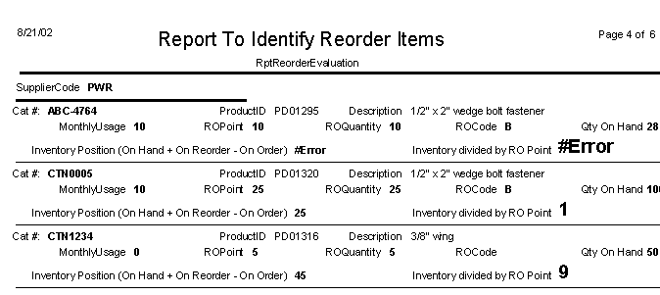

Reorder Evaluation Criteria
This formula equals: ( QuantityOnHand + QuantityReordered – QuantityOrdered ) divided by ROPoint. As this approaches 1 we need to re-order the item.

Customer Database continued

Commissions

FrmMain with CrossReference tab
This is the Main Form with the CrossReference tab activated. This is where you create a way to assign commissions to sales people based on a supplier’s report that would come to you with the supplier’s “Customer Number Ship To” and “Customer Number Bill To”. This table must be completed before you can run the “Monthly Commission Report”. The application uses this table to add the LinkNumber to the TblSalesMonth.

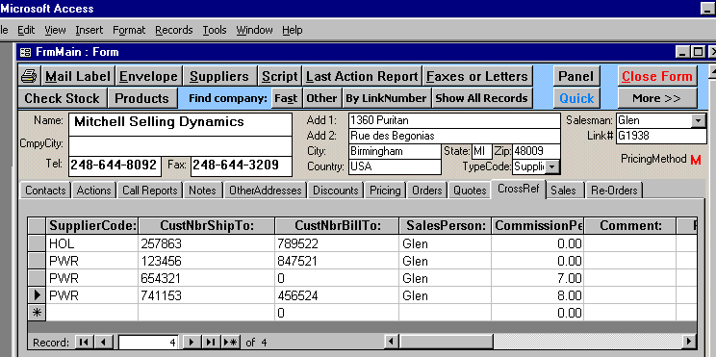
This CustNbrShipTo comes from the Supplier Report
This CustNbrBillTo comes from the Supplier Report

The CustNbrShipTo and CustNbrBillTo must be for the account that is shown at the top, Mitchell Selling Dynamics, in this example. If you cannot find any account in the database for these two numbers then you must add an account.

Fill In Monthly Sales (Panel Button)
This is the Form to be filled in manually with info from the supplier’s monthly report. It can be done automatically if the supplier provides the report as a database file.

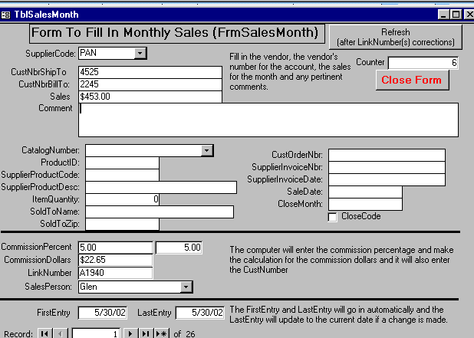
This CustNbrShipTo comes from the Supplier Report
This CustNbrBillTo comes from the Supplier Report
When the sales dollars are added, the application finds the match on the CustNbrShipTo and CustNbrBillTo numbers and adds the appropriate LinkNumber so that the SalesPerson assigned to that LinkNumber can get sales credit. If there is no match a new account must be added with the CustNbrShipTo and CustNbrBillTo numbers put into the CrossReference tab.
Customer Database continued

Commissions continued

Records With No Link Number (Panel Button)
This is the report that can be printed to list the records with no matching LinkNumbers. Once these are identified corrections to CustNbrShipTo or CustNbrBillTo can be made or they can be added to existing accounts or a new account can be added with the CustNbrShipTo or CustNbrBillTo entered in the Cross Reference tab.

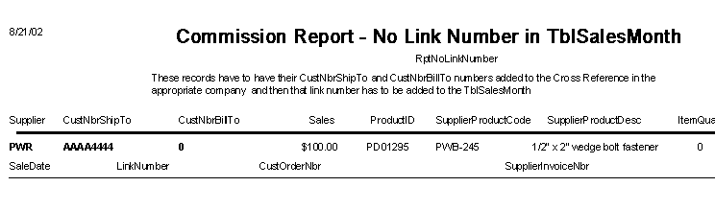

Monthly Commission Report (Panel Button)
After all records in the TblSalesMonth have a LinkNumber, this is the report that can be printed to determine the distribution of commissions from the supplier.
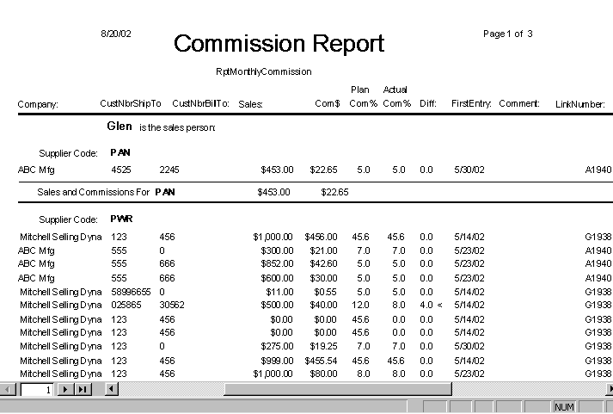

Append Records To Sales (Panel Button)
When the Monthly Commission Report has been printed this button should be clicked to add the TblSalesMonth to TblSales so that the sales figures can be tracked by account.
III. Microsoft Access Database

Replication And Sychronization
If you have a database on your desktop and want to have a copy on another machine (laptop) and be able to make changes in both places when you are not on a LAN, you must periodically sychronize them so that both copies have the same data in them.
- To create the replica or partial replica to be on the laptop click on Tools, Replication, Create Replica

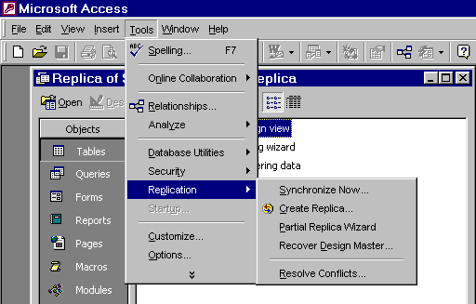
You can create a partial replica to get only one sales person’s records. His partial replica could be sent out to the field for entries to be made while entries are also made at headquarters. Both databases could be synchronized later.

- Once the replica is created it can be downloaded to the other computer and used as required
- The replica from the laptop or other PC would be put on the LAN or on the desktop C: drive for the sychronization process. Once you have a path to both the replica and the master you can open the replica and then click on Tools, Replication, Sychronize and follow the prompts to identify which database to sychronize it to.
- Partial replicas can also be made that involve selecting an individual sales person’s records, providing the record subset to the sales person for updating in the field and then sychronizing them with the headquarter’s master.
Databases: Microsoft Access continued

Replication And Sychronization continued
- Create database in Access (do all the work of creating tables, forms,….,define all relationships etc.)
- Go to Tools and go to “Replication” and select “create replica”.
- This creates a replication set master which will replace your original database and create a database that is the “Design Master” and adds a little disc like icon in front of all objects, such as tables.

Example: Initial Database (This had 3 tables that are linked together)

Table 1.- Companies
Company | City | Sales Person | Link Number
ABC Mfgr | Detroit | Mikey Roman | A1
DEF Mfg | Troy | Mike Roman | A2
XYZ Mfg | Livonia | John Mitchell | A3

Table 2. - Actions
FirstEntry | Action | Link Number
9/17/1999 | Said hello to John | A1
9/17/1999 | Meeting with Tom | A2
9/17/1999 | Meeting with Lou | A3

Table 3. - Contacts
FullName | Title | Link Number
Joe Green | Mgr | A1
Lou Brown | Eng | A1
Tom Smith | Owner | A2
Lucy | Recpt | A2
Bill Leonard | Mgr | A3
Tom Williams | Eng | A3
Cheri | Recpt | A3

This is the Design Master of the original database, created by choosing Tools, Replication, Create replica.
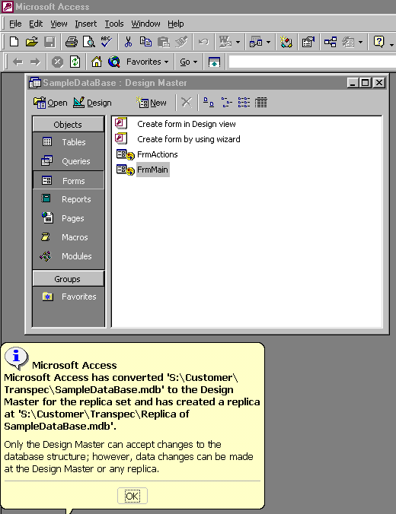
Notice the special icons now next to the objects.
Read this note which explains the actions that have occurred.
Note the title is now Design Master
Databases: Microsoft Access continued

Replication And Sychronization continued

Creating The Partial Replica Database

- To create a Partial Replica, from the “Design Master”, open the Design Master and go to Tools ----Replication ----- Partial Replica Wizard.
- This will create a new database with a record set that is based on criteria established from a field or fields. For example, to set up a partial replication based on one sales person, the criteria for selection would be SalesPerson=’Mike Roman’ in our example.
- This creates the partial replica of the Design Master database with all records that have a sales person equal to ‘Mike Roman’.
- Click “Open the Partial Replica Database” to create your partial replica.
- Now you can make changes to the partial replica and at the same time make changes to the Design Master and then later synchronize them to combine the changes.

Table 1. Companies (in Partial Replica For SalesPerson=Mike Roman)
Company | City | Sales Person | Link Number
DEF Mfg | Troy | Mike Roman | A2

Table 2. Actions (in Partial Replica For SalesPerson=Mike Roman)
FirstEntry | Action | Link Number
9/17/1999 | Meeting with Tom | A2

Table 3. Contacts (in Partial Replica For SalesPerson=Mike Roman)
FullName | Title | Link Number
Tom Smith | Owner | A2
Lucy | Recpt | A2

Synchronizing The Partial Replica Database With The Design Master
- In the Design Master, synchronization is done as follows---Go to ---Tools---Replications---Synchronize now.
- When you synchronize the Partial Replica with the Master Database all changes to both databases will be made in the Design Master and a new Partial Replica can be made again to be sent back to the field.
- If a change in the Partial Replica and the Master Database has been made simultaneously in the same record and the same field with different entries, a pop-up form called Replication Conflict Viewer will be displayed allowing the choice of either entry. (See print screen below)
- For example, if we made a change in the Partial Replica database in the Table Contacts, in the field Title for the second record from Recpt to Receptionist and in the Design Master, Table Contacts, in the field Title for the fourth record from Recpt to Tom’s Assist then the conflict form below would be displayed.
Databases: Microsoft Access continued

Replication And Sychronization continued

Replication Conflict Viewer

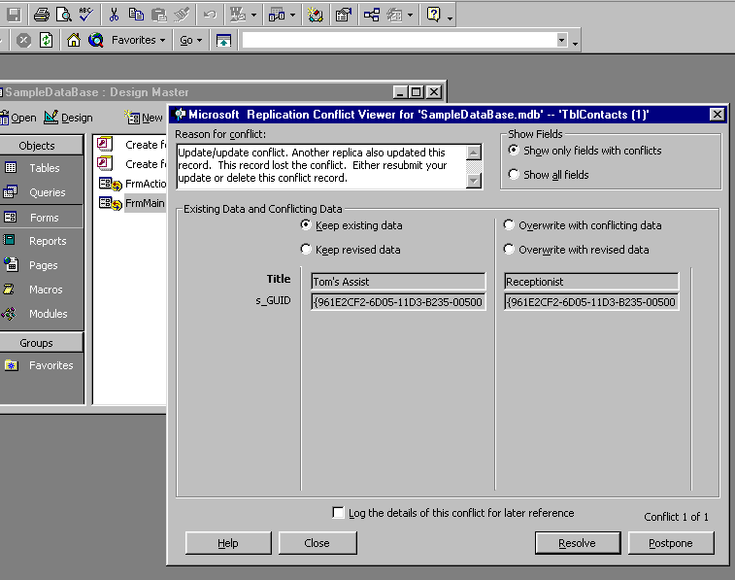
This is the Replication Conflict Viewer. In this example, it shows a conflict in the table contacts and the field title. The
Change made in Design Master
Change made in partial replica

- The conflict can be resolved in several ways. You can keep what is in the Design Master or in the Partial Replica or you can modify either entry and keep either modification.
- Once the two database have been synchronized you can make a new Partial replica and send it to the field for the sales person to load up in their laptop and go about making more changes.
- The system handles adds and deletes done by either the Partial Replica or the Design Master.

